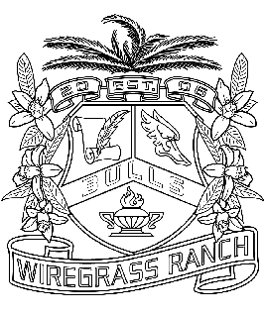
Wiregrass Ranch High School Seniors – Class of 2015 Timeline

Class Sponsor: Ms. Munroe Assistant Principal: Mrs. Butcher
For a senior to attend Grad Bash, Prom, and/or participate in any senior activities, students MUST meet attendance requirements, GPA, and have no OSS. In addition, any student involved with a “Senior Prank” will be removed from all graduation activities including Graduation.
9/19 Student Services Presentation – Gym - Batchelor/Billington
9/30 Senior Seminar- Parent presentation- Media
10/25 Senior Picture Deadline
10/23 – 24 Homecoming Dance Tickets on Sale to Seniors & Juniors
10/27 – 10/31 Homecoming Weeks Activities
11/1 Homecoming Dance - $TBA
10/8 Cap & Gown Presentation/Herff Jones Gym 8:30 – 9:20
(Mandatory Grad Fees: $60 - Includes cap, gown, tassel, medallion,
graduation cost)
10/14 – 10/15 Cap & Gown Orders/Herff Jones - All Lunches – Cafeteria
10/14 Parent Night to order Cap & Gown as well as Fine Paper orders
12/1 Last Day for parents to purchase Senior Yearbook Ads online at
yearbookforever.com
12/20 Deadline to order Cap & Gown/ Announcements
1/13 Senior Panoramic Picture taken during 2nd period and Club Picture Day
1/21 Grad Bash tickets go on sale (Limited Quantity Available) $TBA – Location: TBA- Ms. Munroe Tickets are NON-REFUNDABLE
4/15 Senior Expectations Meeting/Gym/8:30 am
4/25 Grad Bash – Universal Studios - $90
4/27 – 5/1 Senior Spirit Week
5/1 Deadline for completion of all online classes/coursework
5/4 - 15 Advanced Placement (AP) Exams
5/16 Prom 8 pm -12 am - $ TBA
TBA Senior Exam Schedule
5/18 – 19 Senior Checkout and Cap & Gown Distribution in the gym during lunches
5/20 Senior Breakfast and Seniors’ Last day
5/21 Senior Awards Night by Invitation Only
5/21 Senior Grades Due
5/22 Senior Lock-In
TBA Baccalaureate – Gym 6pm – 7pm
5/26 Senior notification
5/27-28 Mandatory Graduation Practice
5/31 Graduation @ USF Sun Dome 10:00 am

- Timeline will be updated as information becomes available.

Ms. Munroe is the contact person, for Senior Information, for all seniors who are not enrolled in a senior English class.

