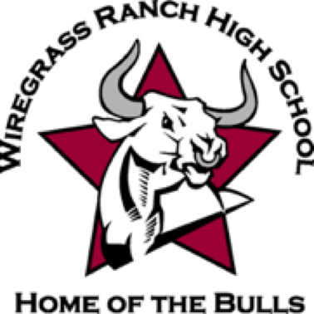Line

Directions: Please complete this application completely and turn it in to Mrs. Packard (4-126 ) or into the Front Office by **Friday, May 14, 2021**. Incomplete or late applications will not be accepted. Please email Mrs. Packard at kpackard@pasco.k12.fl.us or stop by 4-126 with any questions.

Name:

Grade: Student Number:

Regularly checked email address:

Phone Number:

A Ranch Ambassador is an exceptional student who shows pride in being a WRHS Bull. They are helpful, courteous and enjoy meeting new people. Ranch Ambassadors must be On-Track with Bulls PRIDE and maintain a 3.0 GPA. Explain why you would like to be a Ranch Ambassador in the space provided (you may attach a separate sheet if needed).

**RANCH AMBASSADORS**

2021-2022 APPLICATION

Please list activities or organizations below that you were/are involved in that will help you excel in being a Ranch Ambassador:



2.

3.

WRHS Staff Recommendation Signatures:

1.

2.

3.

As a Ranch Ambassador I must attend all meetings, participate in Ranch Ambassador activities, maintain a 3.0 GPA and be a model Bull at WRHS.

Student Signature: Parent/Guardian Signature:

Date: Date: