**At Open House**

The WRHS campus will be open for students and families on August 5, 2021 from 11:30am-3:30pm to visit your students’ teachers, join PTSA, visit club tables, purchase spirit wear, participate in our PTSA Drive To Give fundraiser, and to gear up for 2021-2022 school year!

**Date:** August 5, 2021

**Time:** 11:30 am – 3:30 pm

**Where:** WRHS Campus

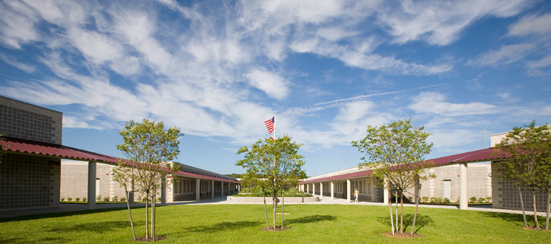

**Prior to August 5th use the MyStudent App To view student schedules, purchase items and pay fees starting July 30th! Bring a copy of your payments on the 5th.**



Wiregrass Ranch

Open House & Meet the Teacher

August 5th 11:30AM-3:30PM

**WRHS’s Open House & Meet the Teacher!**

Dear WRHS Students and Families,

We are excited to start the 2021-2022 school year. Students and families will be able to access their schedules through their myStudent accounts beginning on July 30th, 2021. The myStudent accounts require a 24-hour processing window from activation to be able to view, so please create your account early. If you already have a myStudent account, you will not need to create a new one. Prior to July 30th, make sure you are able to log in successfully.

**Prior to August 5th Open House**

Visit MyStudent to view your schedule, you will be able to walk your schedule and meet your teachers at Open House. You will also need to pay your student fees and purchase any needs for this upcoming school year such as a hall locker, senior fees, PE needs, yearbooks etc... You will bring these receipts with you on the 5th to select your locker and pick up items.

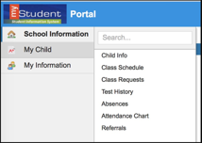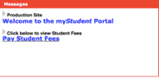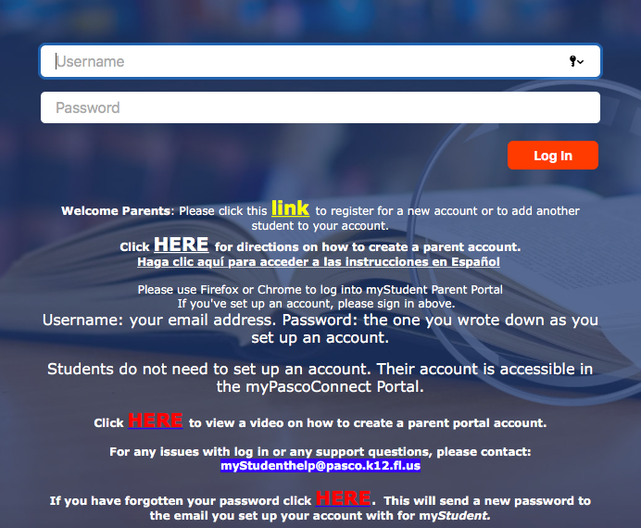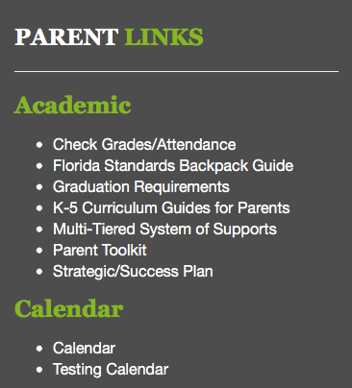

Prior to August 5th, parents ***must***:

* have an active Parent Portal on myStudent.
* have a major credit card available to pay student fees online.

*Students who have not enrolled by July 26 at WRHS are not eligible for this virtual option and will receive their schedules on the first day of school along with directions on how to pay fees.



**myStudent Parent Portal Account Information and Directions**

**STEP 1:** Already a myStudent user?  Do you have a myStudent parent portal account already created?  If yes, skip this step and proceed to step 3 starting July 30th, 2021

If not, then you must create a myStudent parent portal account between now and Wednesday, July 29, 2021 by 5:00pm to ensure that it’s activated in time for orientation.

**TO CREATE A myStudent PARENT PORTAL ACCOUNT:**

1. Navigate to Pasco County Schools website at [www.pasco.k12.fl.us](http://www.pasco.k12.fl.us).
2. Click on the Parents tab.
3. Under Parent Links/Academic click on Check Grades/Attendance.
4. Click the yellow link to create a new Parent Portal.
5. Be sure to complete this process by 5:00pm on July 29, 2021 to be able to participate in the ***Virtual Orientation Day***.

**STEP 2:** The first step is to pay student fees.  There is a link in the messages section of the home page. Click on the text ” Pay Student Fees” to initiate the process.Activate your Parent Portal Account by selecting “Activate Account” on the screen.  Enter the email address associated with your myStudent account and select “Send Email” which generates an email to activate the account. Go to your email and select the link.  Continue by creating your password.  Once this is completed, you will be able to see the school fees based on your student’s courses and any other fees as needed (Seniors will be required to pay their Class of 2022 fee). Now go to step 4!

**STEP 3:** The first step is to pay student fees.  There is a link in the messages section of the home page. Click on the text ” Pay Student Fees” to initiate the process. Now login and pay applicable fees based on your student’s courses and any other fees as needed (Seniors will be required to pay their Class of 2022 fee).

**STEP 4:** After paying fees, return to the myStudent home screen.  Complete the steps below to view the student schedule.

1. Open the “My Child Tab” on the left side of the screen.
2. Open the “Class Schedule” tab in the box that opens to the right.

* The classes listed are the current schedule for your child.  These courses are connected to the fees that have been paid.
* There is a way to print the schedule at the bottom of the screen.
* Note: Schedules could change prior to the start of the school year as we balance and level classes.

We are **not entertaining** schedule change requests during Open House.  We have created a separate system to communicate requests to the assistant principals for each grade level.  You can access the form on the WRHS website, under the Student Services tab on July 30th.