How to sign up for Class Announcements:

- Go to wrhs.pasco.k12.fl.us
- Click “Students” on the top banner.
- Click on “Class of 20xx” (Whichever is your student’s graduation year. This example will be Class of 2023).

- Click on “Class of 2023 Canvas Course”

- Select “I’m a Parent of a Pasco Student”

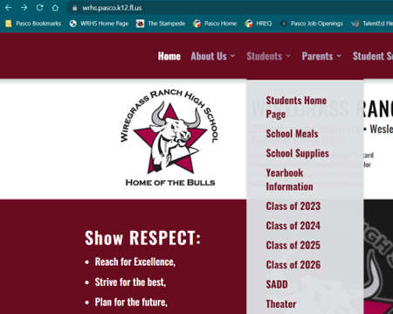

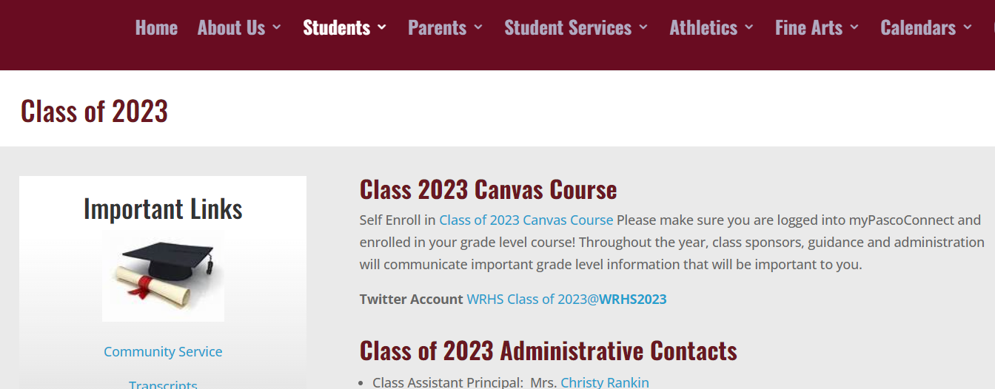

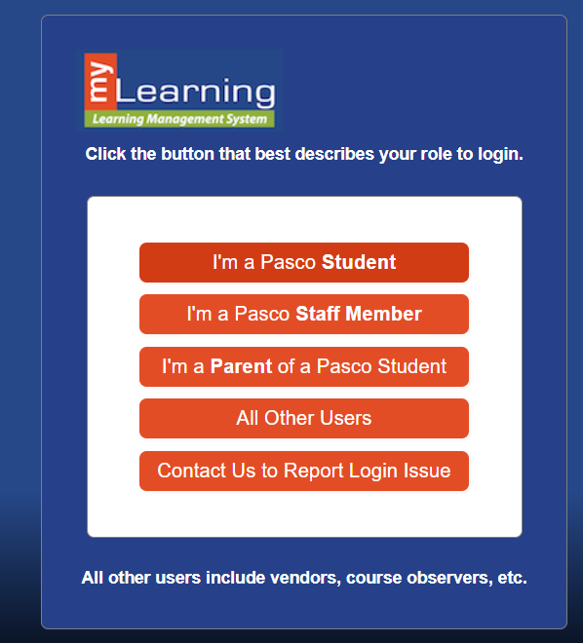
- You will probably have to create a new account for this part. This is a different login than your myStudent login information.

If you need to create an account in myLearning, select “Click Here For an Account” at the top right.

- At the bottom of the Parent Signup form, you will need a Student Pairing Code.

Here is where you can find directions to get a Student Pairing Code: (see note)
https://eschool.pasco.k12.fl.us/parent-account-mylearning/

Note: These directions start in myLearning. You can find this by going to pasco.k12.fl.us, then clicking Parents in the top banner, and navigating down to myLearning

- Enter your new Student Pairing Code and click Start Participating.
You are now enrolled in your student’s Class Announcements and will start receiving emails. Click “Go to the Course” to see previous announcements.

