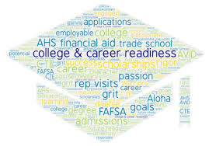  Students (9th-12th) and Parents are welcome to attend  College and Career Planning Presentation  Topics will include: College and career planning resources, post-secondary pathways, applications, scholarships, financial aid, Bright Futures, and more! | Discover how to plan your pathway after high school!  ────  Please bring a laptop. Extra laptops will be available as needed.  ────  Hope to see you there!  ────  RSVP to Mrs. Hensley.  ────  Contact Mrs. Hensley for more information:  khensley@pasco.k12.fl.us  Location:  WRHS  Media Center  Dates:  Tuesday, 9/12 and Tuesday 9/19  5:00pm-6:30pm

