Wiregrass Ranch High School
For Class of 2025 and 2026
Florida College Tour “Beyond the Brochure”
Agenda
Registration Link or use QR Code: https://forms.office.com/Pages/ResponsePage.aspx?id=aaJT4khSVE6bZ7duOoYiIHZf3eFI-lBKnmwJa1kBW81UN0NLRDhQOENUNjFWTVdPNDFMQ08wNTk4QS4u

Day 1 September 25, 2024
6:30am Depart Wiregrass Ransh HS
8:30am Florida Gulf Coast University, Fort Myers
12:30pm Lunch at Florida International University, Miami
1:30pm Florida International University
3:30pm Winwood Falls (Miami Tourist Area)
5:00pm Florida Atlantic University
7:00pm Dinner at Lynn University
10:30pm Hotel near Port St. Lucie

Day 2 September 26, 2024
7:30am Breakfast
9:30am University of Central Florida
11:30am Lunch at UCF
2:30pm Flagler College
4:30pm University of North Florida
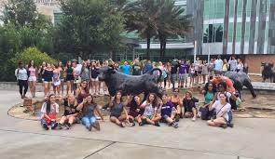
6:00pm Dinner at UNF
11:00pm Arrive at Tallahassee Hotel

Day 3 September 27, 2024
7:00am Breakfast at Hotel
8:00am Florida State University
12:00pm Lunch on Route
2:00pm University of Florida
7:00pm Dinner at USF Hub
8:00pm University of South Florida
10:30pm Arrive Back to Wiregrass Ranch HS
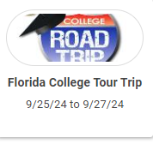
Pay Via “Student Fees” on MyStudent (Parent Portal).
You will have the following options to pay fees:
1. $689.00 Full Payment
2. $344.50 1/2 payment to Register
3. $344.50 Balance owed by 7/31/24

